Regional Conservation Partnerships (RCPs) of Local, Regional, State and National Organizations and Agencies in the CT River Watershed
The CT River Watershed comprises to different degrees the geographies of 12 RCPs, not including Friends of the Silvio Conte (NWR), covering around 50% of the watershed (see map on page 7). Their members represent local, state, multi-state, and national/federal organizations and agencies. Sources for the following information include personal communication (2009-2010) and publicly-available websites (March 2014).

- Mahoosuc Initiative/White Mountains to Moosehead Lake Initiative (NH/ME)
  - 3 Regional Land Trusts
    - Mahoosuc Land Trust
    - Androscoggin River Watershed Council
    - Appalachian Trail Conservancy
  - 1 State Conservation Organization
    - Forest Society of Maine
  - 4 National Conservation Organizations
    - Appalachian Mt. Club
    - Wilderness Society
    - The Trust for Public Land
    - The Conservation Fund (TCF)
  - 1 Business Interest
    - Northern NH Chamber of Commerce
  - 2 Other Organizations
    - Forest Guild
    - Biomass Energy Resource Center (BERC)

- Orange County Headwaters Project (VT)
  - 1 Regional Land Trust
    - Upper Valley Land Trust
  - 1 Statewide Land Trust
    - Vermont Land Trust
  - 2 National Conservation Organization
    - The Nature Conservancy
    - The Conservation Fund
  - 1 State Agency
    - Vermont Fish and Wildlife

- Taylor Valley Conservation Project (VT)
  - 1 Regional Land Trust
    - Upper Valley Land Trust
  - 1 Statewide Land Trust
    - Vermont Land Trust
  - 2 New England/Multistate Conservation Organization
    - New England Forestry Foundation
    - Northeast Wilderness Trust

- Quabbin to Cardigan Partnership (MA/NH)
  - 1 Local Land Trust
    - Harris Center for Conservation Education
  - 6 Regional Land Trusts
    - Ausbon Sargent Land Preservation Trust
    - East Quabbin Land Trust
    - Monadnock Conservancy
    - Mount Grace Land Conservation Trust
    - North County Land Trust,
    - Upper Valley Land Trust
  - 1 Regional Conservation Partnerships
    - North Quabbin Regional Landscape Partnership
  - 4 Statewide Conservation Organizations
    - Massachusetts Audubon
    - New Hampshire Audubon
    - Society for the Protection of New Hampshire Forests
    - The Trustees of Reservations
  - 3 New England, or Multistate Conservation Organizations
    - Appalachian Mountain Club
    - New England Forestry Foundation
    - Highstead Foundation
  - 3 National Conservation Organizations
    - Land Trust Alliance
    - The Nature Conservancy
    - Trust for Public Land,
  - 1 University
    - Harvard Forest, Harvard University

- Chateauguay Notown Conservation Project (VT)
  - Several key landowners
  - 4 Municipalities
    - Town of Killington
    - Tow of Barnard
    - Town of Stockbridge
    - Town of Bridgewater
  - 1 Regional Planning Commission
    - Two Rivers-Ottauquechee Regional Planning Commission
  - 1 Statewide Land Trust
    - Vermont Land Trust
  - 1 National Conservation Organization
    - The Conservation Fund

- MA-VT Woodlands Partnership (MA/VT)
  - 1 Regional Land Trusts
    - Franklin Land Trust (MA)
  - 4 Statewide Land Trusts/Conservation Organizations
    - Vermont Land Trust
    - Audubon Vermont
    - Mass Audubon
    - Vermont Coverts
  - 2 State Agencies
    - MA Department of Conservation and Recreation – Bureau of Forestry
    - VT Forest, Parks and Recreation

- North Quabbin Regional Landscape Partnership (MA)
  - 3 Local Land Trusts/Conservation Organizations
    - Rattlesnake Gutter Trust
    - Athol Bird and Nature Club
    - Millers River Environmental Center
  - 5 Regional Land Trusts
    - East Quabbin Land Trust
    - Franklin Land Trust
    - Kestrel Land Trust
    - Mount Grace Land Conservation Trust
    - North County Land Trust
  - 1 Regional Conservation Partnerships
    - Quabbin to Cardigan Partnership
  - 2 Statewide Conservation Organizations
    - Massachusetts Audubon
    - The Trustees of Reservations
  - 1 New England/Multistate Conservation Organizations
    - New England Forestry Foundation
  - 1 National Conservation Organizations
    - The Nature Conservancy
  - 1Quasi-Municipal Government Organization
    - Franklin Regional Council of Governments
  - 3 State Agencies
    - Massachusetts Division of Conservation Services,
    - Massachusetts Department of Conservation and Recreation
    - MassWildlife (The Division of Fisheries and Wildlife)
  - 3 Federal Agencies
    - National Park Service’s Rivers and Trails and Conservation Assistance Program,
    - U.S. Army Corps of Engineers at Tully Lake, MA
    - U.S. Fish and Wildlife Service
  - 1 University
    - Harvard Forest, Harvard University
  - 1 Business Interests
    - North Quabbin Chamber of Commerce

- Forever Farmland Initiative (MA)
  - 4 Regional Land Trusts
    - Kestrel Land Trust
    - Franklin Land Trust
    - Mount Grace Land Conservation Trust
    - Hilltown Land Trust
  - 1 Statewide Conservation Organizations
    - The Trustees of Reservations
  - 2 National Conservation Organizations
    - Trust for Public Land
    - American Farmland Trust
  - 1 State Agencies
    - Massachusetts Department of Agricultural Resources
  - 2 Agricultural Market Development Organizations
    - CISA – Community Involved in Sustaining Agriculture
    - Pioneer Valley (PV) Grows

- MassConn Sustainable Forest Partnership (MA/CT)
- 1 Local Conservation Organization
    - Norcross Wildlife Sanctuary
- 8 Regional Land Trusts:
    - Opacum Land Trust
    - East Quabbin Land Trust
    - Common Ground Land Trust
    - Minnechaug Land Trust
    - Northern CT Land Trust
    - New Roxbury Land Trust
    - Joshua’s Tract Conservation & Historic Trust
    - Scantic River Watershed Association
- 4 Statewide Conservation Org.:
    - The Trustees of Reservations
    - Mass Audubon
    - CT Forest & Park Association
    - CT Land Conservation Council
- 2 National Conservation Organizations:
    - The Trust for Public Land
    - The Nature Conservancy
- 2 Municipal Commissions
    - Town of Monson Conservation Commission, MA
    - Town of Stafford Conservation Commission, CT
- 3State Agencies:
    - UMass Extension Forest Conservation Program,
    - MassWildlife (MA Dept. of Fish and Game).
    - UConn Forestry & Natural Resources Extension Center,
- 3 Businesses:
    - Gerrish Forestland Products
    - LandVest
    - Hull Forest Products
- 2 Foundations
    - The Norcross Wildlife Foundation
    - Highstead Foundation

- Sandy Brook Corridor Conservation Project (MA/CT)
  - 5 Local Land Trust or Conservation Organization
    - Aton Forest
    - Colebrook Land Conservancy
    - Hartland Land Trust
    - Norfolk Land Trust
    - Winchester Land Trust
  - 3 Watershed Associations
    - Farmington River Coordinating Committee
    - Farmington River Watershed Association
    - Housatonic Valley Association
  - 1 Regional Conservation Partnerships
    - Litchfield Hills Greenprint Collaborative
  - 1 Quasi-Municipal Government Organization
    - Berkshire Natural Resources Council
  - 1 Federal Agency
    - USDA Natural Resources Conservation Service

- Litchfield Hills Greenprint Collaborative (CT)
  - 19 Local Land Trust/Conservation Organization
    - Aton Forest
    - The Cornwall Conservation Trust
    - The Colebrook Land Conservancy
    - The Flanders Nature Center and Land Trust
    - The Goshen Land Trust
    - The Harwinton Land Trust
    - The Kent Land Trust
    - The Morris Land Trust
    - The Naromi Land Trust
    - The Norfolk Land Trust
    - The Roxbury Land Trust
    - The Salisbury Association
    - The Sharon Land Trust
    - The Steep Rock Association
    - The Litchfield Land Trust
    - The New Hartford Land Trust
    - The Warren Land Trust
    - The Watertown Land Trust
    - The Winchester Land Trust
  - 1 Regional Land Trust
    - The Weantinoge Heritage Land Trust
  - 1 Statewide Conservation Organization
    - The Connecticut Farmland Trust
  - 1 Watershed Association
    - The Housatonic Valley Association
  - 3 National Conservation Organizations
    - The Land Trust Alliance
    - The Nature Conservancy
    - The Trust for Public Land

- The Lower CT River and Estuary Region Land Trust Exchange (CT)
  - 14 Local Land Trusts
    - Chester Land Trust
    - Clinton Land Conservation Trust
    - Connecticut River Land Trust
    - Deep River Land Trust
    - East Haddam Land Trust
    - Essex Land Trust
    - Haddam Land Trust
    - Lyme Land Conservation Trust
    - Lynde Point Land Trust
    - Middlesex Land Trust
    - Old Lyme Land Trust
    - Old Saybrook Land Trust
    - Salem Land Trust
    - Westbrook Land Conservation Trust
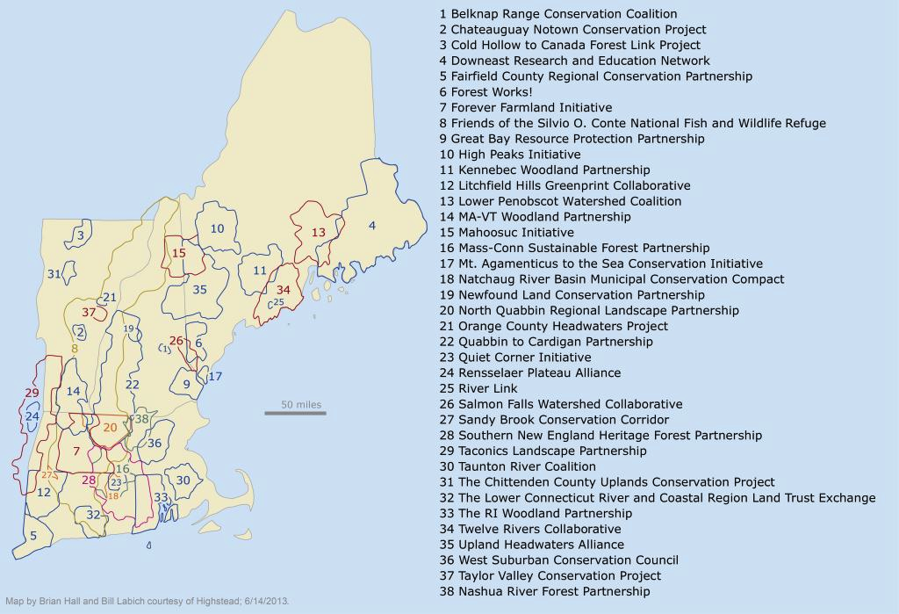
CT River Watershed Boundary
Regional Conservation Partnerships in
New England
RCPs in the CT River Watershed

